

CENTRAL INSTITUTE OF TECHNOLOGY KOKRAJHAR

Deemed to be University, under the MoE, Govt. of India Kokrajhar, BTAD, Assam 783370

[www.cit.ac.i](http://www.cit.ac.in/)n

**Annexure-VI**

**Self-Plagiarism Certificate**

The following published work has been included in the thesis and has not been submitted for any degree to any University/Institute.

1.

2.

3.

4.

5.

6.

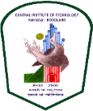**Name and Signature of the Supervisor**

Name: Place: Date

**Name and Signature of the Candidate**

Name: Place: Date